**Learners have to come up with a Report to support the answers to the following questions and suggestions**

Objective Questions

1. Does any table have missing values or duplicates? If yes how would you handle it ?

Query-

-- Checking duplicate and null values in table album--

-- Duplicate--

Select * from album

Select album_id, COUNT(album_id) AS count FROM album GROUP BY album_id HAVING count > 1;

SELECT title, COUNT(title) AS count FROM album GROUP BY title HAVING count > 1;

SELECT artist_id, COUNT(artist_id) AS count FROM album GROUP BY artist_id HAVING count > 1;

-- Null --

SELECT album_id, count(*) FROM album WHERE album_id IS NULL group by album_id;

SELECT title, count(*) FROM album WHERE title IS NULL group by title;

SELECT artist_id, count(*) FROM album WHERE artist_id IS NULL group by artist_id;

-- Checking duplicate and null values in table artist--

-- Duplicate--

Select * from artist

Select artist_id, COUNT(artist_id) AS count FROM artist GROUP BY artist_id HAVING count > 1;

Select name, COUNT(name) AS count FROM artist GROUP BY name HAVING count > 1;

-- Null --

SELECT artist_id, count(*) FROM artist WHERE artist_id IS NULL group by artist_id;

SELECT name, count(*) FROM artist WHERE name IS NULL group by name;

-- Checking duplicate and null values in table customer--

-- Duplicate--

Select * from customer

Select customer_id, COUNT(customer_id) AS count FROM customer GROUP BY customer_id HAVING count > 1;

Select first_name, COUNT(first_name) AS count FROM customer GROUP BY first_name HAVING count > 1;

Select last_name, COUNT(last_name) AS count FROM customer GROUP BY last_name HAVING count > 1;

Select company, COUNT(company) AS count FROM customer GROUP BY company HAVING count > 1;

Select address, COUNT(address) AS count FROM customer GROUP BY address HAVING count > 1;

Select city, COUNT(city) AS count FROM customer GROUP BY city HAVING count > 1;

Select state, COUNT(state) AS count FROM customer GROUP BY state HAVING count > 1;

Select country, COUNT(country) AS count FROM customer GROUP BY country HAVING count > 1;

Select postal_code, COUNT(postal_code) AS count FROM customer GROUP BY postal_code HAVING count > 1;

Select phone, COUNT(phone) AS count FROM customer GROUP BY phone HAVING count > 1;

Select fax, COUNT(fax) AS count FROM customer GROUP BY fax HAVING count > 1;

Select email, COUNT(email) AS count FROM customer GROUP BY email HAVING count > 1;

Select support_rep_id, COUNT(support_rep_id) AS count FROM customer GROUP BY support_rep_id HAVING count > 1;

-- Null --

SELECT customer_id, count(*) FROM customer WHERE customer_id IS NULL group by customer_id;

SELECT first_name, count(*) FROM customer WHERE first_name IS NULL group by first_name;

SELECT last_name, count(*) FROM customer WHERE last_name IS NULL group by last_name;

SELECT company, count(*) FROM customer WHERE company IS NULL group by company;

SELECT address, count(*) FROM customer WHERE address IS NULL group by address;

SELECT city, count(*) FROM customer WHERE city IS NULL group by city;

SELECT state, count(*) FROM customer WHERE state IS NULL group by state;

SELECT country, count(*) FROM customer WHERE country IS NULL group by country;

SELECT postal_code, count(*) FROM customer WHERE postal_code IS NULL group by postal_code;

SELECT phone, count(*) FROM customer WHERE phone IS NULL group by phone;

SELECT fax, count(*) FROM customer WHERE fax IS NULL group by fax;

SELECT email, count(*) FROM customer WHERE email IS NULL group by email;

SELECT support_rep_id, count(*) FROM customer WHERE support_rep_id IS NULL group by support_rep_id;

-- Checking duplicate and null values in table employee--

-- Duplicate--

Select * from employee

Select employee_id, COUNT(employee_id) AS count FROM employee GROUP BY employee_id HAVING count > 1;

Select last_name, COUNT(last_name) AS count FROM employee GROUP BY last_name HAVING count > 1;

Select first_name, COUNT(first_name) AS count FROM employee GROUP BY first_name HAVING count > 1;

Select title, COUNT(title) AS count FROM employee GROUP BY title HAVING count > 1;

Select reports_to, COUNT(reports_to) AS count FROM employee GROUP BY reports_to HAVING count > 1;

Select birthdate, COUNT(birthdate) AS count FROM employee GROUP BY birthdate HAVING count > 1;

Select hire_date, COUNT(hire_date) AS count FROM employee GROUP BY hire_date HAVING count > 1;

Select address, COUNT(address) AS count FROM employee GROUP BY address HAVING count > 1;

Select city, COUNT(city) AS count FROM employee GROUP BY city HAVING count > 1;

Select state, COUNT(state) AS count FROM employee GROUP BY state HAVING count > 1;

Select country, COUNT(country) AS count FROM employee GROUP BY country HAVING count > 1;

Select postal_code, COUNT(postal_code) AS count FROM employee GROUP BY postal_code HAVING count > 1;

Select phone, COUNT(phone) AS count FROM employee GROUP BY phone HAVING count > 1;

Select fax, COUNT(fax) AS count FROM employee GROUP BY fax HAVING count > 1;

Select email, COUNT(email) AS count FROM employee GROUP BY email HAVING count > 1;

-- Null --

SELECT employee_id, count(*) FROM employee WHERE employee_id IS NULL group by employee_id;

SELECT last_name, count(*) FROM employee WHERE last_name IS NULL group by last_name;

SELECT first_name, count(*) FROM employee WHERE first_name IS NULL group by first_name;

SELECT title, count(*) FROM employee WHERE title IS NULL group by title;

SELECT reports_to, count(*) FROM employee WHERE reports_to IS NULL group by reports_to;

SELECT birthdate, count(*) FROM employee WHERE birthdate IS NULL group by birthdate;

SELECT hire_date, count(*) FROM employee WHERE hire_date IS NULL group by hire_date;

SELECT address, count(*) FROM employee WHERE address IS NULL group by address;

SELECT city, count(*) FROM employee WHERE city IS NULL group by city;

SELECT state, count(*) FROM employee WHERE state IS NULL group by state;

SELECT country, count(*) FROM employee WHERE country IS NULL group by country;

SELECT postal_code, count(*) FROM employee WHERE postal_code IS NULL group by postal_code;

SELECT phone, count(*) FROM employee WHERE phone IS NULL group by phone;

SELECT fax, count(*) FROM employee WHERE fax IS NULL group by fax;

SELECT email, count(*) FROM employee WHERE email IS NULL group by email;

-- Checking duplicate and null values in table genre--

-- Duplicate--

Select * from genre

Select genre_id, COUNT(genre_id) AS count FROM genre GROUP BY genre_id HAVING count > 1;

SELECT name, COUNT(name) AS count FROM genre GROUP BY name HAVING count > 1;

-- Null --

SELECT genre_id, count(*) FROM genre WHERE genre_id IS NULL group by genre_id;

SELECT name, count(*) FROM genre WHERE name IS NULL group by name;

-- Checking duplicate and null values in table invoice--

-- Duplicate--

Select * from invoice

Select invoice_id, COUNT(invoice_id) AS count FROM invoice GROUP BY invoice_id HAVING count > 1;

Select customer_id, COUNT(customer_id) AS count FROM invoice GROUP BY customer_id HAVING count > 1;

Select invoice_date, COUNT(invoice_date) AS count FROM invoice GROUP BY invoice_date HAVING count > 1;

Select billing_address, COUNT(billing_address) AS count FROM invoice GROUP BY billing_address HAVING count > 1;

Select billing_city, COUNT(billing_city) AS count FROM invoice GROUP BY billing_city HAVING count > 1;

Select billing_state, COUNT(billing_state) AS count FROM invoice GROUP BY billing_state HAVING count > 1;

Select billing_country, COUNT(billing_country) AS count FROM invoice GROUP BY billing_country HAVING count > 1;

Select billing_postal_code, COUNT(billing_postal_code) AS count FROM invoice GROUP BY billing_postal_code HAVING count > 1;

Select total, COUNT(total) AS count FROM invoice GROUP BY total HAVING count > 1;

-- Null --

SELECT invoice_id, count(*) FROM invoice WHERE invoice_id IS NULL group by invoice_id;

SELECT customer_id, count(*) FROM invoice WHERE customer_id IS NULL group by customer_id;

SELECT invoice_date, count(*) FROM invoice WHERE invoice_date IS NULL group by invoice_date;

SELECT billing_address, count(*) FROM invoice WHERE billing_address IS NULL group by billing_address;

SELECT billing_city, count(*) FROM invoice WHERE billing_city IS NULL group by billing_city;

SELECT billing_state, count(*) FROM invoice WHERE billing_state IS NULL group by billing_state;

SELECT billing_country, count(*) FROM invoice WHERE billing_country IS NULL group by billing_country;

SELECT billing_postal_code, count(*) FROM invoice WHERE billing_postal_code IS NULL group by billing_postal_code;

SELECT total, count(*) FROM invoice WHERE total IS NULL group by total;

-- Checking duplicate and null values in table invoice_line--

-- Duplicate--

Select * from invoice_line

Select invoice_line_id, COUNT(invoice_line_id) AS count FROM invoice_line GROUP BY invoice_line_id HAVING count > 1;

Select invoice_id, COUNT(invoice_id) AS count FROM invoice_line GROUP BY invoice_id HAVING count > 1;

Select track_id, COUNT(track_id) AS count FROM invoice_line GROUP BY track_id HAVING count > 1;

Select unit_price, COUNT(unit_price) AS count FROM invoice_line GROUP BY unit_price HAVING count > 1;

Select quantity, COUNT(quantity) AS count FROM invoice_line GROUP BY quantity HAVING count > 1;

-- Null --

SELECT invoice_line_id, count(*) FROM invoice_line WHERE invoice_line_id IS NULL group by invoice_line_id;

SELECT invoice_id, count(*) FROM invoice_line WHERE invoice_id IS NULL group by invoice_id;

SELECT track_id, count(*) FROM invoice_line WHERE track_id IS NULL group by track_id;

SELECT unit_price, count(*) FROM invoice_line WHERE unit_price IS NULL group by unit_price;

SELECT quantity, count(*) FROM invoice_line WHERE quantity IS NULL group by quantity;

-- Checking duplicate and null values in table media_type--

-- Duplicate--

Select * from media_type

Select media_type_id, COUNT(media_type_id) AS count FROM media_type GROUP BY media_type_id HAVING count > 1;

Select name, COUNT(name) AS count FROM media_type GROUP BY name HAVING count > 1;

-- Null --

SELECT media_type_id, count(*) FROM media_type WHERE media_type_id IS NULL group by media_type_id;

SELECT name, count(*) FROM media_type WHERE name IS NULL group by name;

-- Checking duplicate and null values in table playlist--

-- Duplicate--

Select * from playlist

Select playlist_id, COUNT(playlist_id) AS count FROM playlist GROUP BY playlist_id HAVING count > 1;

Select name, COUNT(name) AS count FROM playlist GROUP BY name HAVING count > 1;

-- Null --

SELECT playlist_id, count(*) FROM playlist WHERE playlist_id IS NULL group by playlist_id;

SELECT name, count(*) FROM playlist WHERE name IS NULL group by name;

-- Checking duplicate and null values in table playlist_track--

-- Duplicate--

Select * from playlist_track

Select playlist_id, COUNT(playlist_id) AS count FROM playlist_track GROUP BY playlist_id HAVING count > 1;

Select track_id, COUNT(track_id) AS count FROM playlist_track GROUP BY track_id HAVING count > 1;

-- Null --

SELECT playlist_id, count(*) FROM playlist_track WHERE playlist_id IS NULL group by playlist_id;

SELECT track_id, count(*) FROM playlist_track WHERE track_id IS NULL group by track_id;

-- Checking duplicate and null values in table track--

-- Duplicate--

Select * from track

Select track_id, COUNT(track_id) AS count FROM track GROUP BY track_id HAVING count > 1;

Select name, COUNT(name) AS count FROM track GROUP BY name HAVING count > 1;

Select album_id, COUNT(album_id) AS count FROM track GROUP BY album_id HAVING count > 1;

Select media_type_id, COUNT(media_type_id) AS count FROM track GROUP BY media_type_id HAVING count > 1;

Select genre_id, COUNT(genre_id) AS count FROM track GROUP BY genre_id HAVING count > 1;

Select composer, COUNT(composer) AS count FROM track GROUP BY composer HAVING count > 1;

Select milliseconds, COUNT(milliseconds) AS count FROM track GROUP BY milliseconds HAVING count > 1;

Select bytes, COUNT(bytes) AS count FROM track GROUP BY bytes HAVING count > 1;

Select unit_price, COUNT(unit_price) AS count FROM track GROUP BY unit_price HAVING count > 1;

-- Null --

SELECT track_id, count(*) FROM track WHERE track_id IS NULL group by track_id;

SELECT name, count(*) FROM track WHERE name IS NULL group by name;

SELECT album_id, count(*) FROM track WHERE album_id IS NULL group by album_id;

SELECT media_type_id, count(*) FROM track WHERE media_type_id IS NULL group by media_type_id;

SELECT genre_id, count(*) FROM track WHERE genre_id IS NULL group by genre_id;

SELECT composer, count(*) FROM track WHERE composer IS NULL group by composer;

SELECT milliseconds, count(*) FROM track WHERE milliseconds IS NULL group by milliseconds;

SELECT bytes, count(*) FROM track WHERE bytes IS NULL group by bytes;

SELECT unit_price, count(*) FROM track WHERE unit_price IS NULL group by unit_price;

To find the missing values or duplicates-

Table: album

|  |  |  |
| --- | --- | --- |
| Column name | Null | Duplicate |
| album_id | 0 | 0 |
| title | 0 | 1 |
| artist_id | 0 | 57 |

Explanation-

* No null value found in any column of table album.
* 1 duplicate value found in title column- Minha Historia
* 57 duplicate rows found in artist_id

Analysis-

* Though the title was repeated twice, but the artist were different as it has two different artist id. So the it cant be ignored.
* 57 distinct artist id have been repeated but the title is different, so it cant be ignored. It means different artist sang different songs.
* We need to consider all the duplicate values because the title, and artist id are not coinciding, so none of the values can be ignored.

Table: artist

|  |  |  |
| --- | --- | --- |
| Column name | Null | Duplicate |
| artist_id | 0 | 0 |
| name | 0 | 0 |

Explanation-

* No duplicate or null value found.

Analysis-

* No null or duplicate value was found.
* If found, we can use: Case statements or Coalesce to remove nulls. For duplicates, we can match the primary key and if it is same, we can combine the rows as one.

Table: customer

|  |  |  |
| --- | --- | --- |
| Column name | Null | Duplicate |
| customer_id | 0 | 0 |
| first_name | 0 | 3 |
| last_name | 0 | 0 |
| company | 49 | 0 |
| address | 0 | 0 |
| city | 0 | 6 |
| state | 29 | 3 |
| country | 0 | 9 |
| postal code | 4 | 0 |
| phone | 1 | 0 |
| fax | 47 | 0 |
| email | 0 | 0 |
| support_rep_id | 0 | 3 |

Explanation-

* Duplicate values were found in first name, city, state, country, support rep id. Since none of them is a primary key and it is possible to have similar information of first name, city, state and country, so it cannot be combined or ignored.
* Null values were found in company, state and fax.

Analysis-

* It is very common to have same first name, also for city, state, and country, many people with same geographic details prefer same song, so we cant combine the data, it has to be treated as different rows.
* For null values in company, state, and fax, we can use coalesce to remove null and add values like- No information available etc.

Table: employee

|  |  |  |
| --- | --- | --- |
| Column name | Null | Duplicate |
| employee_id | 0 | 0 |
| last_name | 0 | 0 |
| first_name | 0 | 0 |
| title | 0 | 2 |
| reports_to | 1 | 3 |
| birth_date | 0 | 0 |
| hire_date | 0 | 0 |
| address | 0 | 0 |
| city | 0 | 2 |
| state | 0 | 1 |
| country | 0 | 1 |
| postal_code | 0 | 0 |
| phone | 0 | 1 |
| fax | 0 | 0 |
| email | 0 | 0 |

Explanation-

* Duplicate values were found in title, reports to, city, state, country, and phone. Since the table contains employee data, it is possible to have multiple employees at a single designation, multiple employees reporting to same manager, and also people hailing from same city, state or country.
* Null value was found in reports_to column. The person is the general manager and is not reporting to anyone, hence it has null value in reports_to.

Analysis-

* It is very common to have same title, city, state, country and phone in the same company.
* For the null value, we can use coalesce and add any value like ‘Not reporting to anyone’, for better clarity.

Table: genre

|  |  |  |
| --- | --- | --- |
| Column name | Null | Duplicate |
| genre_id | 0 | 0 |
| name | 0 | 0 |

Explanation-

* No duplicate or null value found.

Analysis-

* No null or duplicate value was found.
* This shows no genre were repeated.
* If found, we can use: Case statements or Coalesce to remove nulls. For duplicates, we can match the primary key and if it is same, we can combine the rows as one.

Table: invoice

|  |  |  |
| --- | --- | --- |
| Column name | Null | Duplicate |
| invoice_id | 0 | 0 |
| customer_id | 0 | 59 |
| invoice_date | 0 | 100 |
| billing_address | 0 | 59 |
| billing_city | 0 | 53 |
| billing_state | 0 | 26 |
| billing_country | 0 | 24 |
| billing_postal_code | 0 | 56 |
| total | 0 | 19 |

Explanation-

* The primary key, ie, invoice id has no duplicates but rest of the coulmns have duplicates, this shows same customers have made more than 1 purchase.
* No null value present.

Analysis-

* Same customers have made more than 1 purchase which lead to dup-licate values. The difference in count of duplicate values of billing_address, billing_city, billing_state, billing_country, billing_postal_code is because none has been added instead of Null values.
* The company has provided none in place of null values.

Table: invoice_line

|  |  |  |
| --- | --- | --- |
| Column name | Null | Duplicate |
| invoice_line_id | 0 | 0 |
| invoice_id | 0 | 576 |
| track_id | 0 | 1000 |
| unit_price | 0 | 1 |
| quantity | 0 | 1 |

Explanation-

* The primary key, ie, invoice_line_id has no duplicates but rest of the coulmns have duplicates. Invoice_id has a total of 576 duplicates but no invoice_line_id has been repeated it means it is for different line of product. Track_id has duplicates but has been duplicated for different invoice_line_id. All the product has the same cost and only 1 item has been sold.
* No null value present.

Analysis-

* The primary key is not repeated, which shows that it belongs to different line of product.
* No null value found.

Table: media_type

|  |  |  |
| --- | --- | --- |
| Column name | Null | Duplicate |
| media_type_id | 0 | 0 |
| name | 0 | 0 |

Explanation-

* No duplicate or null value found.

Analysis-

* No null or duplicate value was found.
* If found, we can use: Case statements or Coalesce to remove nulls. For duplicates, we can match the primary key and if it is same, we can combine the rows as one.

Table: playlist

|  |  |  |
| --- | --- | --- |
| Column name | Null | Duplicate |
| playlist_id | 0 | 0 |
| name | 0 | 4 |

Explanation-

* No null value found.
* The primary key, ie, the playlist_id has no duplicates but title of the playlist has duplicate

Analysis-

* No null value was found.
* Since the primary key is distinct, all the title will be treated as different rows.

Table: playlist_track

|  |  |  |
| --- | --- | --- |
| Column name | Null | Duplicate |
| playlist_id | 0 | 12 |
| track_id | 0 | 1000 |

Explanation-

* No null value found.
* This consist of different playlist with their playlist_id which contains different tracks.

Analysis-

* No null value was found.
* Different playlist contains different tracks. Playlist are duplicated because many tracks belong to same playlist and vice versa.

Table: track

|  |  |  |
| --- | --- | --- |
| Column name | Null | Duplicate |
| track_id | 0 | 0 |
| name | 0 | 206 |
| album_id | 0 | 265 |
| media_type_id | 0 | 5 |
| genre_id | 0 | 24 |
| composer | 1 | 288 |
| milliseconds | 0 | 381 |
| bytes | 0 | 2 |
| unit_price | 0 | 2 |

Explanation-

* No null value found.
* This table consists of information about different tracks. Name, album_id, media_type_id, genre_id, composer, milliseconds, bytes, and unit_price columns has duplicate values.

Analysis-

* No null value was found.
* Name, album_id, media_type_id, genre_id, composer, milliseconds, bytes, and unit_price columns has duplicate values but since the primary key track_id has no duplicates hence it will be treated as different values and will not be merged.

1. Find the top-selling tracks and top artist in the USA and identify their most famous genres.

Query-

SELECT

t.name AS Track_Name,

ar.name AS Artist_Name,

g.name AS Genre,

SUM(il.quantity) AS Total_Quantity_Sold

FROM track t

JOIN album al ON t.album_id = al.album_id

JOIN artist ar ON al.artist_id = ar.artist_id

JOIN genre g ON t.genre_id = g.genre_id

JOIN invoice_line il ON t.track_id = il.track_id

JOIN invoice i ON il.invoice_id = i.invoice_id

JOIN customer c ON i.customer_id = c.customer_id

WHERE c.country = 'USA'

GROUP BY t.name, ar.name, g.name

ORDER BY Total_Quantity_Sold DESC

LIMIT 10;

Method-

* Join the tables- track, album, artist, genre, invoice_line, invoice, customer
* Filter the customer country to USA
* Group the result by tracks, artist and genre
* Order by total quantity sold in desc order to show top sellers
* Put a limit of 10

Analysis-

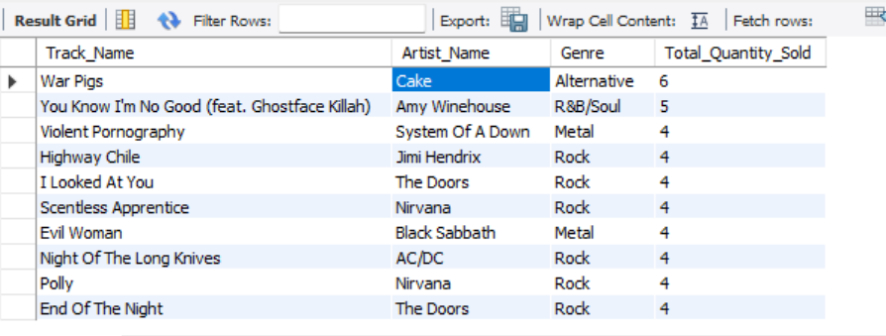

Insights-

* Rock is the most popular genre being sold in the USA.
* War Pig with 6 units by Cake is the most sold track in the USA.
* Artists like Nirvana, The Door appear more than once in the list, which shows their high popularity in the USA.

1. What is the customer demographic breakdown (age, gender, location) of Chinook's customer base?

Query-

-- **Query 1 ** --

SELECT CONCAT(first_name, ' ', last_name) AS full_name, city, state, country

FROM customer

GROUP BY first_name, last_name, city, state, country;

-- **Query 2 ** --

SELECT country, COUNT(*) AS customer_count

FROM customer

GROUP BY country

order by customer_count desc

limit 10;

Method-

* Since no date of birth and gender is provided, we can only make the breakdown with the name, city, state and country.
* There are two queries written, the first query gives the detail information of the customer, its full name, city, state and country, whereas the second query tells us count of customer in each country. In the second query arrange the count of customers in descending order by appling the limit of 10.

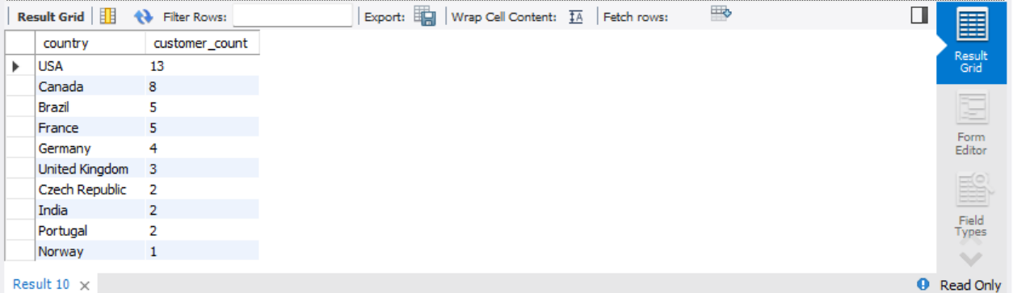Analysis-

Insights-

* The majority of customer base of chinook is from the USA following behind with Canada, Brazil and France.

1. Calculate the total revenue and number of invoices for each country, state, and city:

Query

Query 1- Total Revenue by Country, State, and City:

SELECT billing_country, billing_state, billing_city, SUM(total) AS total_revenue

FROM invoice

GROUP BY billing_country, billing_state, billing_city

ORDER BY total_revenue DESC limit 10;

Query 2- Number of invoices for each country, state, and city. --

SELECT billing_country, billing_state, billing_city, COUNT(invoice_id) AS number_of_invoices

FROM invoice

GROUP BY billing_country, billing_state, billing_city

ORDER BY number_of_invoices DESC LIMIT 10;

Method-

* Two separate queries have been used for total revenue and the number of invoices
* Query 1- Total Revenue
* Query 2- Number of invoices
* Billing country, state, and city have been selected with the sum of the total column to find out the total revenue for each country, state and city. The result has been grouped as per billing country, state and city and has been arranged in descending order of the sum to find the highest revenues with a limit of 10.
* Billing country, state, and city have been selected with the count of invoice id to find out the number of invoices for each country, state and city. The result has been grouped as per billing country, state and city and has been arranged in descending order of the count to find the highest number of invoices with a limit of 10.

Analysis-

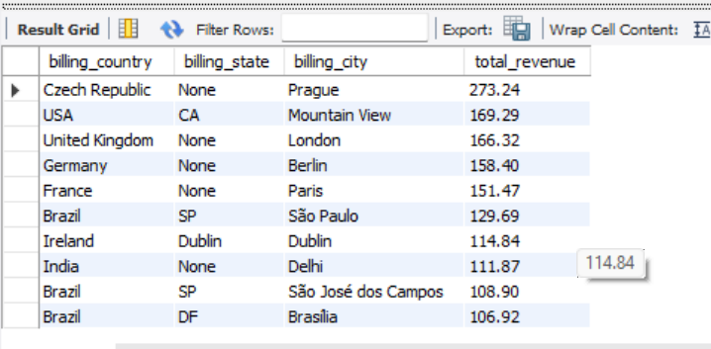Query 1- Total Revenue by Country, State, and City:

Query 2- Number of invoices for each country, state, and city.

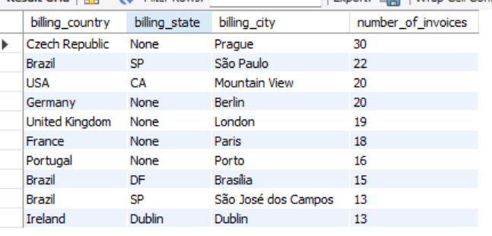

Insights-

* Czech Republic (City- Prague), USA (State- CA, City- Mountain View), United Kingdom (City- London) has the highest total revenue.
* Czech Republic (City- Prague), Brazil (State- SP, City- Sao Paulo), USA (State- CA, City- Mountain View) has the highest number of invoices.

1. Find the top 5 customers by total revenue in each country

Query-

SELECT c.customer_id, concat(c.first_name,' ',c.last_name) as full_name, c.country,

SUM(i.total) AS total_revenue

FROM customer c

JOIN invoice i ON c.customer_id = i.customer_id

GROUP BY c.customer_id,concat(c.first_name,' ',c.last_name), c.country

ORDER BY total_revenue DESC, c.country

limit 5;

Method-

* Identify the required tables- Customer and invoice
* We will join both tables on customer id.
* Total revenue will be taken from invoice table and customer id, country, first and last name will be taken from customer table.
* The result has to be grouped on customer id, country and full name for better clarity.
* As per the question limit has been set to 5 and the revenue has been arranged in descending order to obtain the customer which has generated the highest revenue.

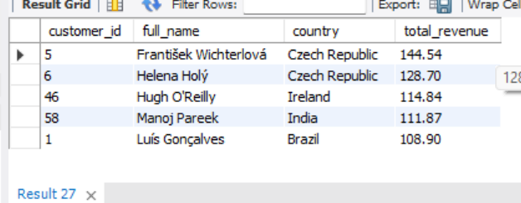Analysis-

Insights-

* Customer with customer id 5 of country Czech Republic has generated the highest revenue.
* Customer with customer id 6 of country Czech Republic has generated the second highest revenue.
* Customer with customer id 46 of country Ireland has generated the third highest revenue.
* Customer with customer id 58 of country India has generated the fourth highest revenue.
* Customer with customer id 1 of country Brazil has generated the fifth highest revenue.

1. Identify the top-selling track for each customer

Query-

WITH Cte AS (

SELECT c.customer_id, c.first_name, c.last_name, t.track_id, t.name AS track_name,

SUM(il.unit_price * il.quantity) AS total_revenue,

ROW_NUMBER() OVER (PARTITION BY c.customer_id ORDER BY SUM(il.unit_price * il.quantity) DESC) AS revenue_rank

FROM customer c

JOIN invoice i ON c.customer_id = i.customer_id

JOIN invoice_line il ON i.invoice_id = il.invoice_id

JOIN track t ON il.track_id = t.track_id

GROUP BY c.customer_id, c.first_name, c.last_name, t.track_id, t.name

)

SELECT customer_id, first_name, last_name, track_id, track_name, total_revenue

FROM Cte

WHERE revenue_rank = 1

ORDER BY total_revenue desc, customer_id;

Method-

* Start by identifying the necessary tables.
* We will use common table expression for ease of work.
* Join the invoice_line table with the invoice table using the invoice_id to obtain the corresponding customer_id.
* Next, link this result with the customer table via the customer_id to retrieve customer details.
* Then, join this combined data with the track table using the track_id to get track-related information.
* Group the data by customer_id and track_id to analyze track purchases per customer.
* Calculate the total quantity sold for each track by summing the quantity column.
* Assign ranks to the tracks for each customer based on total quantity sold, and sort it in descending order.
* Finally, filter the result to show only the top track (highest sales) for each customer.
* In the end order it by total revenue in descending order.

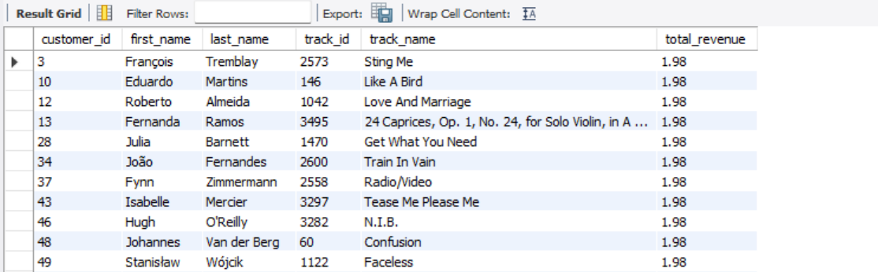Analysis*:*

Insights-

* Customer 3 has purchased track 2573 twice, making it their top-selling track.
* Customer 10 has purchased track 146 twice, making it their top-selling track.
* Customer 12 has purchased track 1042 twice, making it their top-selling track.
* Customer 13 has purchased track 3495 twice, making it their top-selling track.
* Customer 28 has purchased track 1470 twice, making it their top-selling track.
* Customer 34 has purchased track 2600 twice, making it their top-selling track.
* Customer 37 has purchased track 2558 twice, making it their top-selling track.
* Customer 43 has purchased track 3297 twice, making it their top-selling track.
* Customer 46 has purchased track 3282 twice, making it their top-selling track.
* Customer 48 has purchased track 60 twice, making it their top-selling track.
* Customer 49 has purchased track 1122 twice, making it their top-selling track.

1. Are there any patterns or trends in customer purchasing behavior (e.g., frequency of purchases, preferred payment methods, average order value)?

Query-

Frequency of purchases-

SELECT c.customer_id,c.first_name,c.last_name,

COUNT(i.invoice_id) AS purchase_frequency

FROM customer c

JOIN invoice i ON c.customer_id = i.customer_id

GROUP BY c.customer_id

ORDER BY purchase_frequency DESC

limit 10;

Preferred payment methods-

No information Provided for payment method

Average order value-

SELECT c.customer_id,c.first_name,c.last_name,

Round(AVG(i.total)) AS average_order_value

FROM customer c

JOIN invoice i ON c.customer_id = i.customer_id

GROUP BY c.customer_id

ORDER BY average_order_value DESC

limit 10;

Method-

-- Frequency of purchases –

* Identify the table containing required information and join it.
* Table customer and invoice has been joined on customer id.
* For calculating frequency, count of invoice id has been taken.
* Grouping is done on customer id.
* Records are sort in descending order as per frequency to show the highest on the top.

-- Preferred payment methods –

* No information provided for payment method

-- Average order value –

* Identify the table containing required information and join it.
* Table customer and invoice has been joined on customer id.
* For calculating average, average of total value has been taken from invoice table, it is rounded off to avoid complex values.
* Grouping is done on customer id.
* Records are sort in descending order as per average of total to show the highest on the top.

Average-

-- Frequency of purchases –

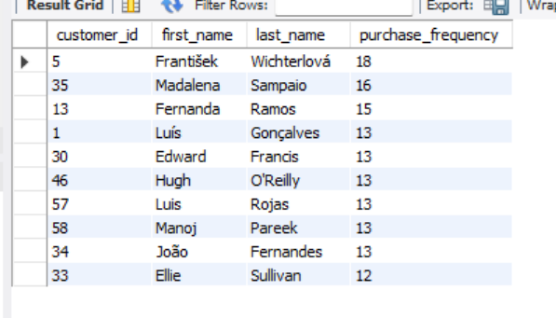

-- Average order value –

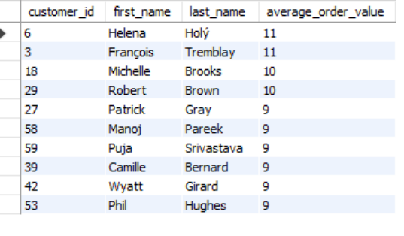

Insights-

-- Frequency of purchases –

* A pattern can be seen in the frequency.
* As, customer with customer id 5 purchases a lot of tracks with a frequency of 18 followed for customer with customer id 35 and 13 with frequency of 16 and 15 respectively.

-- Average order value –

* A pattern can be seen in the average.
* Customer with customer id 6 and 13 have the highest average value of 11

1. What is the customer churn rate?

Query-

Calculate the oldest date/year-

SELECT c.customer_id, MIN(i.invoice_date) AS first_invoice_date

FROM customer c

JOIN invoice i ON c.customer_id = i.customer_id

GROUP BY c.customer_id

limit 1

Calculate the recent date/year -

SELECT c.customer_id, MAX(i.invoice_date) AS first_invoice_date

FROM customer c

JOIN invoice i ON c.customer_id = i.customer_id

GROUP BY c.customer_id

limit 1

Count Unique Customers in 2017-

SELECT COUNT(DISTINCT customer_id) AS customer_count_2017

FROM invoice

WHERE YEAR(invoice_date) = 2017;

Count Unique Customers in 2020-

SELECT COUNT(DISTINCT customer_id) AS customer_count_2020

FROM invoice

WHERE YEAR(invoice_date) = 2020;

**Churn Rate**-

SELECT COUNT(DISTINCT customer_id) AS churned_customers

FROM invoice

WHERE YEAR(invoice_date) = 2017

AND customer_id NOT IN (

SELECT DISTINCT customer_id

FROM invoice

WHERE YEAR(invoice_date) = 2020

);

Method-

* The first query shows at which date/year the purchase began.
* The next query shows at which date/year the purchase began.
* The next query shows the unique customer id in 2017 (oldest year)
* The next query shows the unique customer id in 2020 (latest year)
* The last quesy shows the count of unique customer id which were lost in 2020

Formula used-

Customer Churn rate-

(Lost customer/Total customer at the start of period)X 100

= (1/58) * 100 = 1.72

Insights-

* The churn rate is low, which indicates high customer retention.
* This shows that only 1 customer who was part of the purchase in 2017 is not a part of it in 2020.

1. Calculate the percentage of total sales contributed by each genre in the USA and identify the best-selling genres and artists.

Query-

WITH GenreSales AS (

SELECT g.name AS genre,

SUM(il.unit_price * il.quantity) AS total_sales

FROM Invoice i

JOIN Invoice_Line il ON i.invoice_id = il.invoice_id

JOIN Track t ON il.track_id = t.track_id

JOIN Genre g ON t.genre_id = g.genre_id

JOIN Customer c ON i.customer_id = c.customer_id

WHERE c.country = 'USA'

GROUP BY g.name

),

TotalSales AS (

SELECT SUM(total_sales) AS total_sales_amount

FROM GenreSales)

SELECT gs.genre,gs.total_sales,

(gs.total_sales / ts.total_sales_amount * 100) AS sales_percentage

FROM GenreSales gs

CROSS JOIN TotalSales ts

ORDER BY gs.total_sales DESC

LIMIT 10;

Method- WHERE c.country = 'USA'

* The Genre_Sales CTE calculates the total sales for each genre in the USA by summing up the product of unit_price and quantity for each genre.
* The Total_Sales CTE calculates the total sales amount across all genres by summing the values from the Genre_Sales CTE.
* The final SELECT query calculates what percentage of total sales comes from each genre by dividing genre sales by total sales and multiplying by 100.
* The results are sorted in descending order of sales to emphasize the top-performing genres.

Analysis-

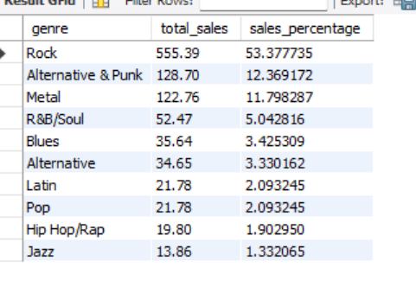

Insights-

* The genre Rock, bags the highest sales of $555.36 with the percentage of 53.377.
* The genre Alternative & Punk, bags the second highest sales of $128.70 with the percentage of 12.36.
* The genre Metal, bags the third highest sales of $122.76 with the percentage of 11.79.

1. Find customers who have purchased tracks from at least 3 different genres

Query-

SELECT c.customer_id, concat(c.first_name," ", c.last_name) as Full_name,

COUNT(DISTINCT g.genre_id) AS genre_count

FROM customer c

JOIN invoice i ON c.customer_id = i.customer_id

JOIN invoice_line il ON i.invoice_id = il.invoice_id

JOIN track t ON il.track_id = t.track_id

JOIN genre g ON t.genre_id = g.genre_id

GROUP BY c.customer_id, c.first_name,c.last_name

HAVING genre_count >= 3

limit 10;

Method-

* To identify the required tables. Join customer, invoice, invoice line, track and genre table.
* Use count distinct of genre id to calculate the total number of genre purchased by each customer.
* Group the results by customer name, customer id and genre.
* Filter the results to get information about only those customers who purchased atleast 3 genre.
* Limit the result upto 10.

Analysis-

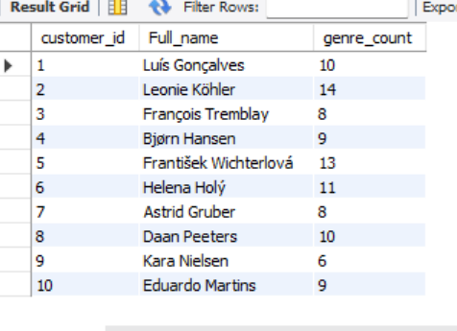

1. Rank genres based on their sales performance in the USA

Query-

SELECT g.name AS genre,

RANK() OVER (ORDER BY SUM(il.unit_price * il.quantity) DESC) AS sales_rank

FROM genre g

JOIN track t ON g.genre_id = t.genre_id

JOIN invoice_line il ON t.track_id = il.track_id

JOIN invoice i ON il.invoice_id = i.invoice_id

GROUP BY g.name

ORDER BY sales_rank;

Method-

* Identify the required tables- Invoice,track, genre.
* Use where clause to filter the result of USA.
* Order the result by descending order of sales

Analysis-

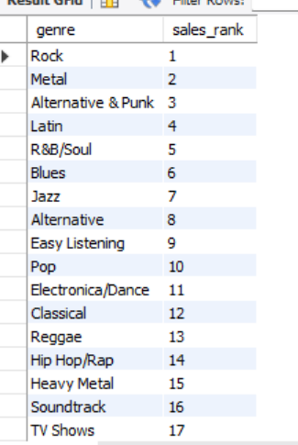

Insights-

* Rock secured the first rank in terms of descending order of total sales.
* Metal secured the second rank in terms of descending order of total sales.
* Alternative & Punk secured the third rank in terms of descending order of total sales.
* Latin secured the fourth rank in terms of descending order of total sales.

1. Identify customers who have not made a purchase in the last 3 months

Query-

SELECT c.customer_id, concat(c.first_name," ", c.last_name) as full_name

FROM customer c

WHERE c.customer_id NOT IN (

SELECT DISTINCT i.customer_id

FROM invoice i

WHERE i.invoice_date >= DATE_SUB(CURRENT_DATE, INTERVAL 3 MONTH)

);

Method-

* Select customer id and customer name from customers table which are not present in the list of customer id who have made purchase in the recent 3 months.

Analysis-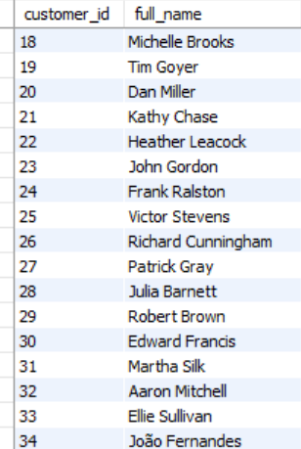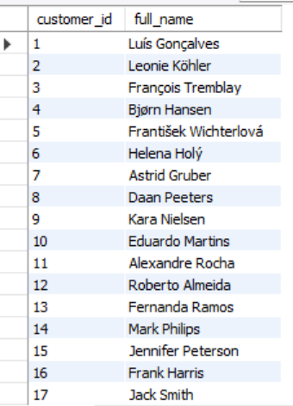

Insights-

* A total of 59 customers have not made any purchase in the last 3 months, which is a significantly high number.

Subjective Questions

1. Recommend the three albums from the new record label that should be prioritised for advertising and promotion in the USA based on genre sales analysis.

Query-

SELECT g.name AS genre_name,

SUM(il.unit_price * il.quantity) AS total_sales

FROM invoice_line il

JOIN invoice i ON il.invoice_id = i.invoice_id

JOIN track t ON il.track_id = t.track_id

JOIN album a ON t.album_id = a.album_id

JOIN genre g ON t.genre_id = g.genre_id

WHERE i.billing_country = 'USA'

GROUP BY g.name

ORDER BY total_sales DESC

LIMIT 3;

Method-

* Identify the required tables.
* Join invoice_line, invoice, track, and genre table.
* Filter the country as USA
* Use the aggregate filter SUM to add the multiplication of unit price and quantity as total sales.
* Group the required data with the genre name.
* Arrange the result in the descending order of total sales.
* Put a limit of 3 to show only 3 records.

Analysis-

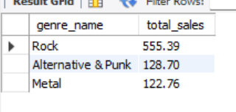

Insights-

The three albums from the new record label that should be prioritised for advertising and promotion in the USA based on genre sales analysis are-

* The genre Rock has the highest sales
* The genre Alternative & Punk has the second highest sales
* The genre Metal has the third highest sales

Promoting these 3 will gain more profit and will yield best results as per the current market trend in USA.

1. Determine the top-selling genres in countries other than the USA and identify any commonalities or differences.

Query-

WITH Genre_Sales AS (

SELECT i.billing_country AS Country,g.name AS Genre,

SUM(il.unit_price * il.quantity) AS TotalSales

FROM invoice_line il

JOIN invoice i ON il.invoice_id = i.invoice_id

JOIN track t ON il.track_id = t.track_id

JOIN genre g ON t.genre_id = g.genre_id

WHERE i.billing_country != 'USA'

GROUP BY i.billing_country, g.name),

Top_Genres AS (

SELECT Country,Genre,TotalSales,

ROW_NUMBER() OVER (PARTITION BY Country ORDER BY TotalSales DESC) AS row_no

FROM Genre_Sales)

SELECT Country,Genre,TotalSales

FROM Top_Genres

WHERE row_no = 1

ORDER BY Country;

Method-

* Use 2 common table expressions. First as genre_sales to analyse total sales for each country except for USA. Second as top_genres to assign a rank to each genre within a country.
* In the end use select statement to select all genres from each country except USA with rank 1.

Analysis-

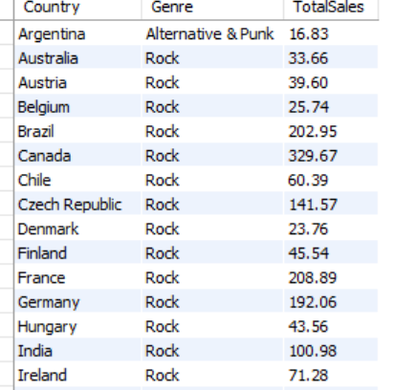

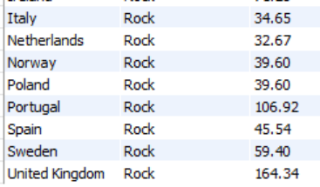

Commonalities-

* Rock can be seen as a top genre for many countries, indicating broad scope throughout international market

Insights-

* Rock should be a key focus for global marketing due to its widespread popularity.
* Leverage Rock's global appeal to drive international music promotion strategies.

1. Customer Purchasing Behavior Analysis: How do the purchasing habits (frequency, basket size, spending amount) of long-term customers differ from those of new customers? What insights can these patterns provide about customer loyalty and retention strategies?

Query-

First purchase date of each customer-

SELECT c.customer_id, MIN(i.invoice_date) AS first_purchase_date

FROM customer c

JOIN invoice i ON c.customer_id = i.customer_id

GROUP BY c.customer_id;

Divide the customer into long term and new customer-

SELECT c.customer_id,

CASE WHEN MIN(i.invoice_date) < DATE_SUB(CURDATE(), INTERVAL 1 YEAR) THEN 'Long_term'ELSE 'New'

END AS customer_type

FROM customer c

JOIN invoice i ON c.customer_id = i.customer_id

GROUP BY c.customer_id;

Purchasing Frequency-

SELECT ct.customer_type,c.customer_id,COUNT(i.invoice_id) AS purchase_frequency

FROM (SELECT c.customer_id,

CASE WHEN MIN(i.invoice_date) < DATE_SUB(CURDATE(), INTERVAL 1 YEAR) THEN 'Long-term'ELSE 'New'

END AS customer_type

FROM customer c

JOIN invoice i ON c.customer_id = i.customer_id

GROUP BY c.customer_id) ct

JOIN customer c ON ct.customer_id = c.customer_id

JOIN invoice i ON c.customer_id = i.customer_id

GROUP BY ct.customer_type, c.customer_id;

Basket Size-

SELECT ct.customer_type,c.customer_id,ROUND(AVG(il.quantity)) AS average_basket_size

FROM (SELECT c.customer_id,

CASE WHEN MIN(i.invoice_date) < DATE_SUB(CURDATE(), INTERVAL 1 YEAR) THEN 'Long-term'ELSE 'New'

END AS customer_type

FROM customer c

JOIN invoice i ON c.customer_id = i.customer_id

GROUP BY c.customer_id) ct

JOIN customer c ON ct.customer_id = c.customer_id

JOIN invoice i ON c.customer_id = i.customer_id

JOIN invoice_line il ON i.invoice_id = il.invoice_id

GROUP BY ct.customer_type, c.customer_id;

Spending Amount-

SELECT ct.customer_type,c.customer_id,SUM(i.total) AS total_spending

FROM (SELECT c.customer_id,

CASE WHEN MIN(i.invoice_date) < DATE_SUB(CURDATE(), INTERVAL 1 YEAR) THEN 'Long-term'ELSE 'New'

END AS customer_type

FROM customer c

JOIN invoice i ON c.customer_id = i.customer_id

GROUP BY c.customer_id) ct

JOIN customer c ON ct.customer_id = c.customer_id

JOIN invoice i ON c.customer_id = i.customer_id

GROUP BY ct.customer_type, c.customer_id;

Method-

* Calculate the first purchase date of each customer.
* Divide the database into Lomg term and new customer.
* Analyse its frequency, basket size and spending amount.

Analysis-

* Purchasing Frequency- **Long-Term customers** buy more often, suggesting higher engagement and trust. **New customers** on the other hand have less frequency may be due to them exploring the options.
* Basket Size- **Long-Term customers** often have a larger average basket size, reflecting their familiarity with and trust in the product range. **New customers** may initially have a smaller basket size, but they could potentially increase it as they become more comfortable with the offerings.
* Spending Amount- **Long-term customers** contribute more to total spending**.**

Insights-

* Focus should be on customer retention.
* Loyalty or reward points to be offers.

1. Product Affinity Analysis: Which music genres, artists, or albums are frequently purchased together by customers? How can this information guide product recommendations and cross-selling initiatives?

Query-

Genre Pairs-

SELECT g1.name AS genre1, g2.name AS genre2, COUNT(*) AS frequency

FROM invoice_line il1

JOIN track t1 ON il1.track_id = t1.track_id

JOIN genre g1 ON t1.genre_id = g1.genre_id

JOIN invoice_line il2 ON il1.invoice_id = il2.invoice_id

JOIN track t2 ON il2.track_id = t2.track_id

JOIN genre g2 ON t2.genre_id = g2.genre_id

WHERE il1.invoice_line_id < il2.invoice_line_id AND g1.name <> g2.name

GROUP BY g1.name, g2.name

ORDER BY frequency DESC

LIMIT 10;

Artist Pairs-

SELECT a1.name AS artist1, a2.name AS artist2, COUNT(*) AS frequency

FROM invoice_line il1

JOIN track t1 ON il1.track_id = t1.track_id

JOIN album al1 ON t1.album_id = al1.album_id

JOIN artist a1 ON al1.artist_id = a1.artist_id

JOIN invoice_line il2 ON il1.invoice_id = il2.invoice_id

JOIN track t2 ON il2.track_id = t2.track_id

JOIN album al2 ON t2.album_id = al2.album_id

JOIN artist a2 ON al2.artist_id = a2.artist_id

WHERE il1.invoice_line_id < il2.invoice_line_id AND a1.name <> a2.name

GROUP BY a1.name, a2.name

ORDER BY frequency DESC

LIMIT 10;

Album pair-

SELECT al1.title AS album1, al2.title AS album2, COUNT(*) AS frequency

FROM invoice_line il1

JOIN track t1 ON il1.track_id = t1.track_id

JOIN album al1 ON t1.album_id = al1.album_id

JOIN invoice_line il2 ON il1.invoice_id = il2.invoice_id

JOIN track t2 ON il2.track_id = t2.track_id

JOIN album al2 ON t2.album_id = al2.album_id

WHERE il1.invoice_line_id < il2.invoice_line_id

AND al1.title <> al2.title

GROUP BY al1.title, al2.title

ORDER BY frequency DESC

LIMIT 10;

Method-

* Identify the genre pair, artist pair and album pairs.
* Calculate its frequency

Analysis-

* Genre pairs

Rock and Metal have been purchased for about 871 times. It shows high favourability in customers.

Rock has been repeated a lot of times, further investments can be made in rock genre.

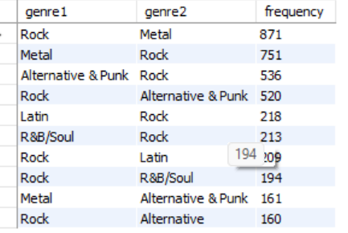

* Artists Pair

System of a down and Jimi Hendrix have been together purchased for 13 times.

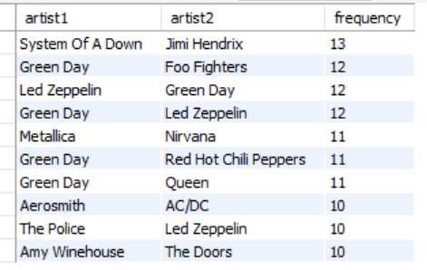

* Album Pair

Albums like Mezmerize and Are you experienced has been brought together for 13 times shows customer preferences.

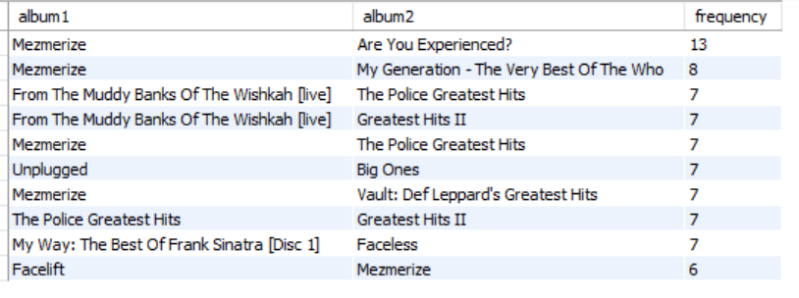Insights-

* Discounts and combo deals on frequently purchased genres and albums can be used as a good advertising strategy worldwide.

Cross selling initiatives-

* Offer bundles on artists who are purchased together.

Product recommendations-

* Use high frequency purchases as a guide for new customers with proper data to authenticate it.

1. Regional Market Analysis: Do customer purchasing behaviors and churn rates vary across different geographic regions or store locations? How might these correlate with local demographic or economic factors?

Query-

Customer purchasing behavior-

SELECT c.country, c.city, COUNT(DISTINCT i.invoice_id) AS total_purchases,

SUM(il.unit_price * il.quantity) AS total_spending,

(Round(AVG(il.unit_price * il.quantity))) AS avg_spending_per_purchase,

COUNT(DISTINCT c.customer_id) AS total_customers

FROM customer c

JOIN invoice i ON c.customer_id = i.customer_id

JOIN invoice_line il ON i.invoice_id = il.invoice_id

GROUP BY c.country, c.city

ORDER BY total_spending DESC

LIMIT 5;

Churn rates-

WITH customer_last_purchase AS (

SELECT c.customer_id,MAX(i.invoice_date) AS last_purchase_date,c.country,c.city

FROM customer c

JOIN invoice i ON c.customer_id = i.customer_id

GROUP BY c.customer_id, c.country, c.city

)

SELECT country,city,COUNT(*) AS total_customers,

SUM(CASE WHEN DATEDIFF(CURDATE(), last_purchase_date) > 365 THEN 1 ELSE 0 END) AS churned_customers,

(SUM(CASE WHEN DATEDIFF(CURDATE(), last_purchase_date) > 365 THEN 1 ELSE 0 END) / COUNT(*)) * 100 AS churn_rate

FROM customer_last_purchase

GROUP BY country, city

ORDER BY churn_rate DESC

limit 5;

Method-

* Identify the customer purchasing behaviour- Segment the country-city wise data of purchases, their speding and also the number of customer with each country-city.
* Calculate the churn rates- Measure purchasing frequency, average spending, and churn rates for each region.

Analysis-

Purchasing behaviour-

* **Total Purchases & Spending**: Regions like the **USA and Canada** show high total spending, likely due to larger customer bases and higher disposable incomes.
* **Average Spend per Purchase**: Higher average spending in certain regions suggests **greater willingness to pay** for music content.

Churn Rates

* High Churn Regions: Some European cities show higher churn, indicating a need for improved engagement or localized campaigns.
* Low Churn Regions: Areas with low churn may reflect effective retention practices that could be replicated elsewhere

Correlation with Demographics & Economics

* Demographics: Younger regions tend to favor genres like Pop and Hip-Hop, influencing buying behavior.
* Economics: Wealthier regions often show higher spend and lower churn, driven by stronger purchasing power.

Insights-

* Targeted Marketing: Customize campaigns by region — premium promotions in affluent areas, discounts in high-churn markets.
* Customer Retention: Implement region-specific loyalty offers, localized content, and tailored support.
* Product Localization: Align the catalog with regional music tastes, featuring popular genres and artists per location.

1. Customer Risk Profiling: Based on customer profiles (age, gender, location, purchase history), which customer segments are more likely to churn or pose a higher risk of reduced spending? What factors contribute to this risk?

Query-

Customers with No Recent Purchases-

SELECT c.customer_id, c.first_name, c.last_name, c.country, MAX(i.invoice_date) AS last_purchase_date

FROM customer c

JOIN invoice i ON c.customer_id = i.customer_id

GROUP BY c.customer_id, c.first_name, c.last_name, c.country

HAVING MAX(i.invoice_date) < DATE_SUB(CURDATE(), INTERVAL 1 YEAR);

Customers by Spending Patterns-

SELECT c.customer_id, c.first_name, c.last_name, c.country,

COUNT(i.invoice_id) AS purchase_count,

SUM(i.total) AS total_spent,

AVG(i.total) AS avg_spent_per_purchase,

MAX(i.invoice_date) AS last_purchase_date

FROM customer c

JOIN invoice i ON c.customer_id = i.customer_id

GROUP BY c.customer_id, c.first_name, c.last_name, c.country

ORDER BY total_spent DESC

LIMIT 5;

Customer Segments by Location-

SELECT c.country,

COUNT(c.customer_id) AS total_customers,

COUNT(i.invoice_id) AS total_purchases,

SUM(i.total) AS total_revenue,

AVG(i.total) AS avg_revenue_per_purchase,

MAX(i.invoice_date) AS last_purchase_date

FROM customer c

JOIN invoice i ON c.customer_id = i.customer_id

GROUP BY c.country

ORDER BY total_revenue DESC

LIMIT 5;

Purchase Frequency and Recency-

SELECT c.customer_id, c.first_name, c.last_name, c.country,

COUNT(i.invoice_id) AS purchase_count,

DATEDIFF(CURDATE(), MAX(i.invoice_date)) AS days_since_last_purchase,

CASE

WHEN DATEDIFF(CURDATE(), MAX(i.invoice_date)) > 365 THEN 'High Risk'

WHEN DATEDIFF(CURDATE(), MAX(i.invoice_date)) BETWEEN 180 AND 365 THEN 'Medium Risk'

ELSE 'Low Risk'

END AS risk_profile

FROM customer c

JOIN invoice i ON c.customer_id = i.customer_id

GROUP BY c.customer_id, c.first_name, c.last_name, c.country

Limit 5;

Method-

* Determine customer with no recent purchase, which shows chured customers, spending pattern of the customer, customer segments by location, customer purchase Frequency and Recency.

Analysis-

Factors-

* Customer with no recent purchase- They pose high threat of churned customers
* Spending pattern of the customer- Reduction in spending pattern may lead to losses.
* Customer segments by location- Locations like USA, Canada, Brazil may have a higher concentration of at-risk customers.
* Customer purchase Frequency and Recency- Customers with no recent activity are more likely to churn

1. Customer Lifetime Value Modeling: How can you leverage customer data (tenure, purchase history, engagement) to predict the lifetime value of different customer segments? This could inform targeted marketing and loyalty program strategies. Can you observe any common characteristics or purchase patterns among customers who have stopped purchasing?

Query-

Customer tenure-

SELECT c.customer_id, c.first_name, c.last_name, c.country, MIN(i.invoice_date) AS first_purchase_date, MAX(i.invoice_date) AS last_purchase_date, COUNT(i.invoice_id) AS purchase_count, SUM(i.total) AS total_spent

FROM customer c

JOIN invoice i ON c.customer_id = i.customer_id

GROUP BY c.customer_id;

Purchase history-

SELECT i.customer_id, il.invoice_line_id, il.track_id, il.unit_price, il.quantity, t.album_id, t.genre_id

FROM invoice_line il

JOIN invoice i ON il.invoice_id = i.invoice_id

JOIN track t ON il.track_id = t.track_id;

Engagement-

SELECT t.track_id, a.album_id, ar.artist_id, ar.name AS artist_name

FROM track t

JOIN album a ON t.album_id = a.album_id

JOIN artist ar ON a.artist_id = ar.artist_id;

Method-

* Calculate customer tenure- Identify by find the first and last purchase date, how many purchases were made in between them and the total spent.
* Calculate customer purchase history- Identify the purchase history by using the invoice line table. How many times the same or different customer purchased the same or different product.
* Calculate engagements- Present the combination of track id, album id, artist id and name

Insights-

* Customers with **longer tenures** and **frequent purchases** generally have higher Customer Lifetime Value.

1. If data on promotional campaigns (discounts, events, email marketing) is available, how could you measure their impact on customer acquisition, retention, and overall sales?

Query-

Customer Acquisition-

SELECT MIN(i.invoice_date) AS first_purchase_date,

COUNT(DISTINCT i.customer_id) AS new_customers

FROM invoice i

JOIN customer c ON i.customer_id = c.customer_id

WHERE i.invoice_date BETWEEN '2018-01-01' AND '2018-01-31'

GROUP BY i.customer_id

HAVING first_purchase_date BETWEEN '2018-01-01' AND '2018-01-31';

Customer retention-

SELECT COUNT(DISTINCT i2.invoice_id) AS repeat_purchases,COUNT(DISTINCT i1.customer_id) AS total_customers

FROM invoice i1

JOIN invoice i2 ON i1.customer_id = i2.customer_id

WHERE i1.invoice_date BETWEEN '2018-01-01' AND '2018-01-31'AND i2.invoice_date > '2018-01-31';

Overall sales comparison-

SELECT SUM(CASE WHEN i.invoice_date BETWEEN '2017-12-01' AND '2017-12-31' THEN i.total ELSE 0 END) AS before_campaign_sales,

SUM(CASE WHEN i.invoice_date BETWEEN '2018-01-01' AND '2018-01-31' THEN i.total ELSE 0 END) AS during_campaign_sales,

SUM(CASE WHEN i.invoice_date BETWEEN '2020-02-01' AND '2020-02-28' THEN i.total ELSE 0 END) AS after_campaign_sales

FROM invoice i;

Method-

* Customer Acquisition- Write a query to find the MIN date which is the promotion start date, count of the customers that made a purchase during that promotion period, filter the period using where clause, also group the result using customer id.
* Customer retention- Write a query who made purchase in January and also later to show retention. Join is performed with the same table on customer id.
* Overall sales comparison- A query is written from invoice table, using case statement to calculate the sales before, after and during promotional periods.

Analysis

* Customer Acquisition-

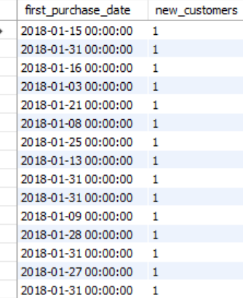

* Customer retention-

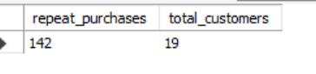

* Overall sales comparison-

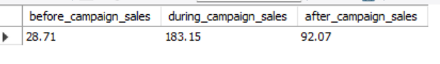

Recommendation-

* Enhance customer retention tactics
* Implement post campaign check ups
* Proper monitoring of sales
* Note which campaign led to the most sales generation

1. How would you approach this problem, if the objective and subjective questions weren't given?

Query-

Customer Acquisition-

SELECT COUNT(DISTINCT customer_id) AS new_customers

FROM invoice

WHERE invoice_date BETWEEN '2018-01-01' AND '2018-01-31'

AND customer_id NOT IN (SELECT customer_id FROM invoice

WHERE invoice_date < '2018-01-01'

);

Customer retention-

SELECT COUNT(DISTINCT i1.customer_id) AS retained_customers

FROM invoice i1

JOIN invoice i2 ON i1.customer_id = i2.customer_id

WHERE i1.invoice_date < '2018-01-01'

AND i2.invoice_date BETWEEN '2018-01-01' AND '2018-01-31';

Overall sales comparison-

SELECT

SUM(CASE WHEN invoice_date BETWEEN '2017-12-01' AND '2017-12-31' THEN total ELSE 0 END) AS sales_before,

SUM(CASE WHEN invoice_date BETWEEN '2018-01-01' AND '2018-01-31' THEN total ELSE 0 END) AS sales_during_campaign,

SUM(CASE WHEN invoice_date BETWEEN '2018-02-01' AND '2018-02-28' THEN total ELSE 0 END) AS sales_after

FROM invoice;

Understand the concept-

* The first thing would be to understand the business, what is really happening, and what needs to be done.

Objectives-

* Increase sales performance, understand metrics, customer retention, and lower churn rate.

Explore and Analyse the dataset-

* Use of SQL queries to find out the sales, churn rate, customer retention rate, region wise sales analysis and steps taken to enhance it.
* Join multiple tables to find complex data and their resulting solutions.
* Use aggregate functions like SUM, COUNT, MIN, MAX to find the overall sales, customer frequency, tenure etc.

Derive Insights-

* Which genre performed well, in which state, city or country. Promotion campaigns or customer preference what lead to it.
* Which album is most preferred?
* Combination sets of most preferred artists, album or genre sets.
* Rock is the most preferred genre is many countries.
* Combine tracks or album or genre with rock as an offer to increase sales.
* Using customer purchase trend as a major factor for increasing sales/ campaigns/ promotions.

Suggest Recommendations-

* Launch region specific campaigns.
* Promote employee motivation schemes to enhance sales and healthy competition
* Promote underperforming album/genre/artist/track.

1. How can you alter the "Albums" table to add a new column named "ReleaseYear" of type INTEGER to store the release year of each album?

Query-

ALTER TABLE album

ADD COLUMN ReleaseYear INTEGER;

Select * from album;

Method-

* Use query-

ALTER TABLE album

ADD COLUMN ReleaseYear INTEGER;

Analysis-

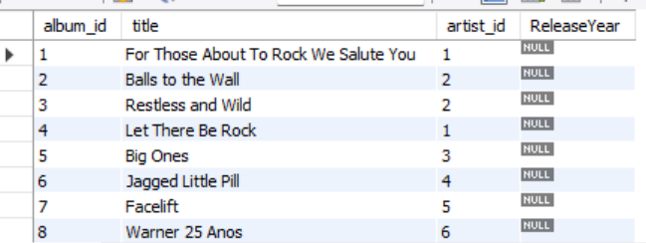

1. Chinook is interested in understanding the purchasing behavior of customers based on their geographical location. They want to know the average total amount spent by customers from each country, along with the number of customers and the average number of tracks purchased per customer. Write an SQL query to provide this information.

Query-

WITH customer_spending AS (

SELECT c.customer_id, c.country, SUM(i.total) AS total_spent, COUNT(il.track_id) AS total_tracks

FROM customer c

JOIN invoice i ON c.customer_id = i.customer_id

JOIN invoice_line il ON i.invoice_id = il.invoice_id

GROUP BY c.customer_id, c.country

),

Country_summary AS (

SELECT country, COUNT(customer_id) AS number_of_customers,

ROUND(AVG(total_spent))AS avg_total_spent,

ROUND(AVG(total_tracks)) AS avg_tracks_per_customer

FROM customer_spending

GROUP BY country

)SELECT country, number_of_customers, avg_total_spent, avg_tracks_per_customer

FROM Country_summary

ORDER BY country;

Method-

To find-

* Average total amount spent by customers from each country.
* Number of customers
* Average number of tracks purchased per customer

Analysis-

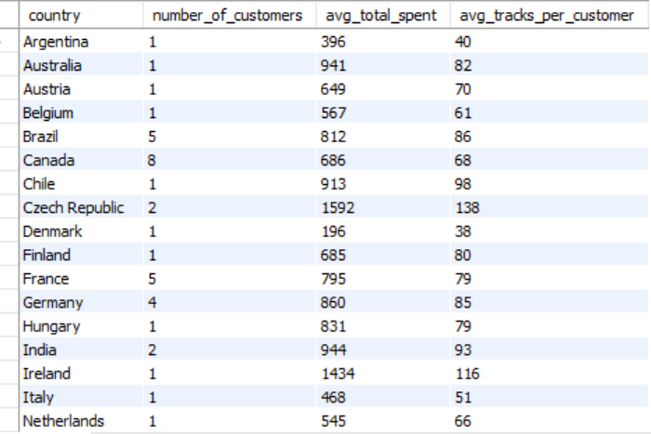

High- Value Markets

* Germany and Canada  
  Customers from these regions exhibit high average spending, indicating strong market potential for premium offerings and loyalty programs.

Largest Market, Untapped Potential

* United States  
  Despite having the largest customer base, the average spend per customer is just moderate.

Low Engagement Region

* Brazil  
  Shows lower average tracks purchased per customer, suggesting less engagement.

Stable Market

* France  
  Displays balanced customer count and consistent purchasing, indicating a steady market with room for gradual growth.